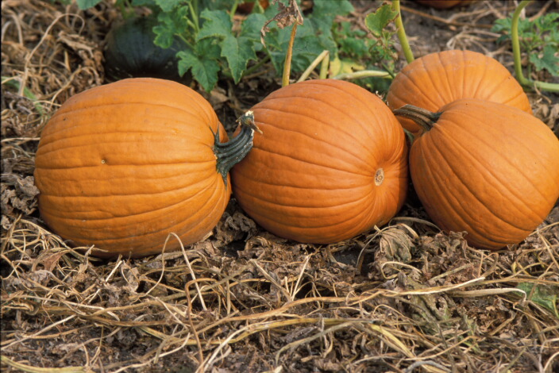
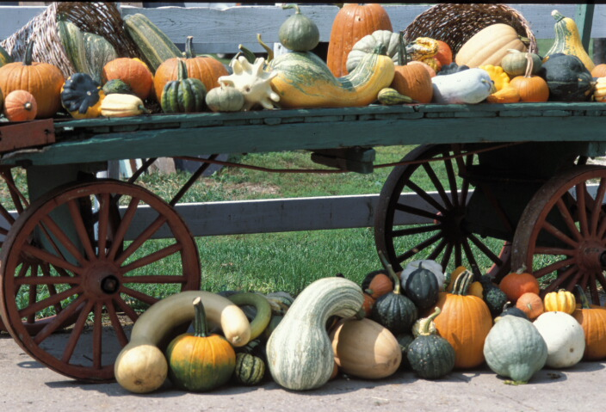
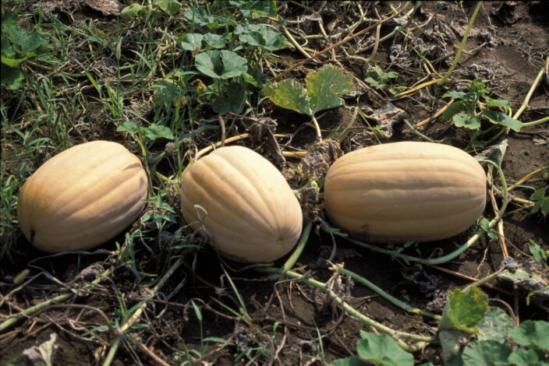
ILLINOIS PUMPKIN DAY - 2006

PLACE: Vegetable Crops Research Farm at Champaign, IL

DATE: September 8, 2006
TIME: 10:00 A.M. – 2:00 P.M.
PRESENTATIONS: All on Research Plots
John Swiader and Bill Shoemaker: Fertility/Production Trials
Bill Shoemaker and Maurice Ogutu: Mulching Trial
Chuck Voigt and Alan Walters: Variety Trial
John Masiunas and Elizabeth Wahle: Herbicide & Planting System Trials
Rick Weinzierl: Insect Pests
M. Babadoost and Sushma Jossey: Disease Trials

John Swiader, Dept. of NRES, University of Illinois (phone: 217-333-6872).
Bill Shoemaker, St. Charles Hort. Research Center, University of Illinois (phone: 630- 584-7254).
Maurice Ogutu, Countryside Extension Center, University of Illinois (phone: 708-352-0109630)).

Charles Voigt, Dept. of NRES, University of Illinois (phone: 217-333-1969).
Alan Walters, Southern Illinois University (phone: 618-453-3446).
John Masiunas, Dept. of NRES, University of Illinois (phone: 217-244-4469).
Elizabeth Wahle, Edwardsville Extension Center, University of Illinois (phone: 618- 692-9434).
Richard Weinzierl, Dept. of Crop Sciences, University of Illinois (phone: 217-333-6651).
Mohammad Babadoost, Dept. of Crop Sciences, University of Illinois (phone: 217-333-1523).
Sushma Jossey, Dept. of Crop Sciences, University of Illinois (phone: 217-244-8027).

Registration is free and lunch will be provided.

The opportunity exists to also see other vegetable research plots.
Illinois is the leading state in pumpkin production. Approximately 90% of processing pumpkins produced in the United States are grown in Illinois.

Sponsors will be acknowledged later. If you want to be a sponsor of the Pumpkin Day, please send your contribution to M. Babadoost (N-533 Turner Hall, 1102 S. Goodwin Ave., Urbana, IL 61801). For more information on the Pumpkin Day, contact M. Babadoost (phone: 217-333-1523; E-mail: babadoos@uiuc.edu).

Approaching Champaign-Urbana:

Interstate I-74, from the West: Take Prospect Ave. exit (Exit 181) south to Windsor Road (~4 miles); turn left on Windsor Rd. (~1/2 mile east); turn right to First St. (~1/4 mile south).

Interstate I-74 from the East. Take Lincoln Ave. exit (Exit 183) south to Windsor Road (~4 miles); turn right on Windsor Rd. (~1 mile west); turn right to First St. (~1/4 mile south).

Interstate I-57 from the North: Take I-74 east to Prospect Ave. exit (Exit 181) south to Windsor Road (~4 miles); turn right on Windsor Rd. (~1 mile west); turn right to First St. (~1/4 mile south).

Interstate I-57 from the South: Take Monticello-Savoy Exit (Exit 229) to US 45; turn right to Windsor Rd. ((~1/4 mile east); turn right to First St. (~1/4 mile south).

Interstate I-72: Take University Ave. to Prospect Ave exit; south on Prospect to Windsor Rd. (~2 miles); turn left on Windsor Rd. ((~1/2 mile south); turn right to First St. (~1/4 mile south).

ILLINOIS PUMPKIN DAY-2006

Registration Form

Participant(s) information:

Name(s): ____________________ ______ _________________________
(First) (M.I.) (Last)

____________________ ______ _________________________
(First) (M.I.) (Last)

____________________ ______ _________________________
(First) (M.I.) (Last)

____________________ ______ _________________________
(First) (M.I.) (Last)

____________________ ______ _________________________
(First) (M.I.) (Last)

Address: _______________________________ ___________________ ____ __________
(Street) (City) (State) (Zip code)

Day Phone: ( )__________ Evening Phone: ( )____________ Cell Phone: ( )____________

Fax: ( )_________________

Email: _____________________________________

Your occupation:

Please register by September 7, 2006. To prepare for the field tours and lunch, early registration will be appreciated.

To register, fill out the form and return it:

As an email attachment to: M. Babadoost (babadoos@uiuc.edu) or Andrew Jurgens (ajurg@uiuc.edu)
OR
Fax it to: M. Babadoost (217-333-5299)
OR
Mail it to: M. Babadoost, N-533 Turner Hall, Department of Crop Sciences, 1102 S. Goodwin Ave., Urbana, IL 61801.

For additional information, contact M. Babadoost by phone at 217-333-1523 or email at babadoos@uiuc.edu.

